**WEEK 1**

Lexical analyser

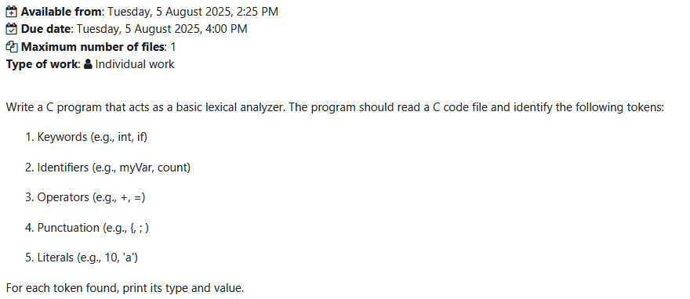

**WEEK 2**

Regular expression to dfa

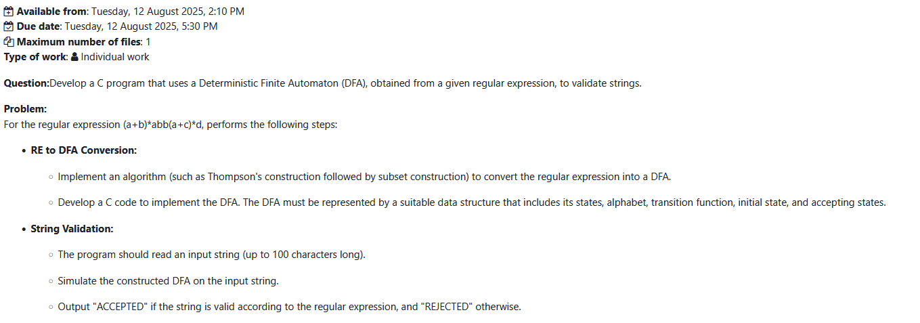

**WEEK 3**

Cfg string accept or reject

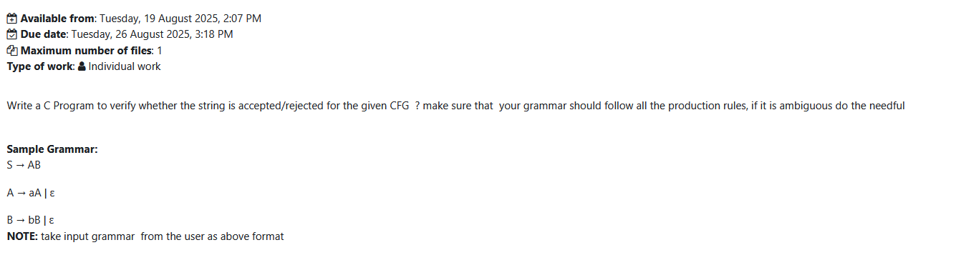

**WEEK 4**

Left recursion

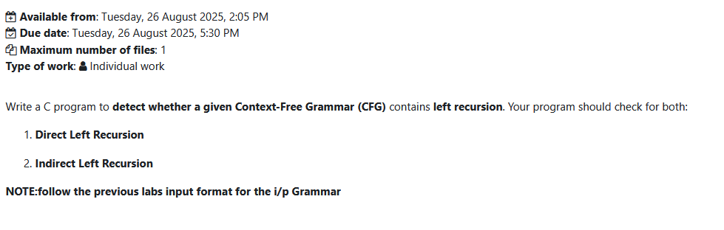

Left recursion conversion



**WEEK 5**

Left factoring

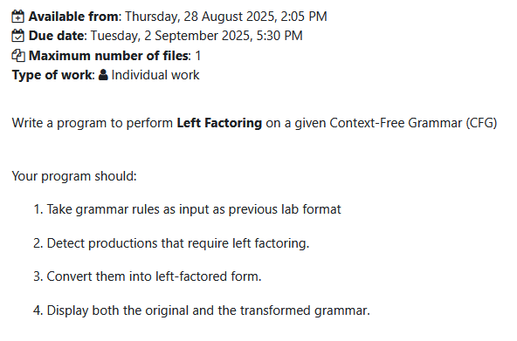

**WEEK 6**

First and follow

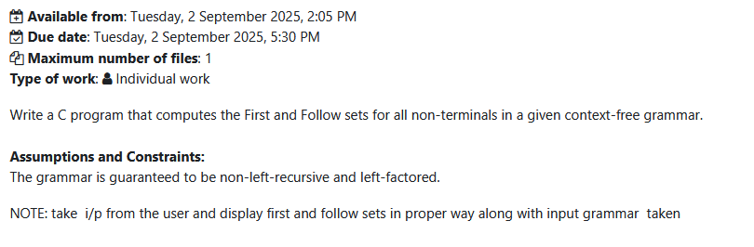

**WEEK 7**

Ll1 parser

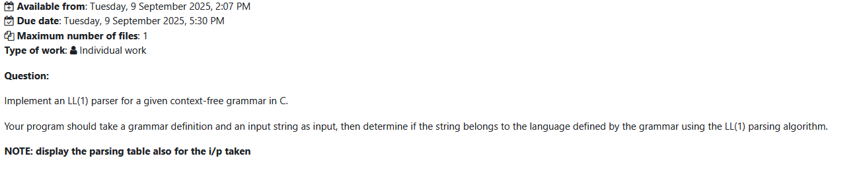

**WEEK 8**

Recursive decent parser

